**The Effects of Visual Imagery on Recall Memory: Dual Coding or Depth of Processing?**

Zoe Ziv

Department of Psychological & Brain Sciences, University of California, Santa Barbara

PSY 117L: Laboratory in Memory & Cognition

Dr. Mary Hegarty

December 7, 2024

**Abstract**

In this study, we examined how mental imagery and pictorial (visual) memory traces impact explicit recall memory. We aimed to clarify whether visual mental imagery improves memory by forming both visual and verbal memory traces (dual coding) or by processing visually-imagined stimuli more deeply and effortfully (depth of processing). Sixty-seven participants were randomly assigned to three conditions and completed a recall test consisting of 15 stimuli. The control group (mental rehearsal) was presented with words only, the visual imagery group was shown the same words and instructed to form a mental image of the words, and the dual coding group was shown the words with a corresponding image. We hypothesized that the control group would have significantly worse recall performance than both the visual imagery and dual coding groups. Furthermore, we examined three alternative hypotheses, proposing that the visual imagery group could have better, worse, or equal recall performance compared to dual coding. Our results revealed a significant difference between the three conditions, as both the visual imagery and dual coding groups recalled significantly more words than the control group, supporting our hypothesis. There was no difference between the visual imagery and dual coding groups, consistent with Paivio and Csapo’s (1973) dual coding theory. Thus, we concluded that visual imagery enhances memory similarly to viewing actual images by producing both visual and verbal cues. These findings show that pictorial traces, for both imagined and actual images, improve memory (i.e., have positive memory effects), highlighting the effectiveness of visual imagery as a memorization strategy. This research contributes to knowledge in learning and memory and has broader applications within education and healthcare.

*Keywords:* memory, learning, memorization strategies, visual mental imagery,

dual coding

**The Effects of Visual Imagery on Recall Memory: Dual Coding or Depth of Processing?**

Cognitive psychologists have long studied various strategies to enhance memory and learning, aiming to understand and improve this function that our brain constantly performs. As such, researchers have examined how mental imagery and visual cues improve memory, studying their effectiveness as memorization strategies. Comparing memorization strategies expands our knowledge in the domains of learning and memory and elucidates the most optimal strategies. This research has practical applications in education and healthcare, benefiting both students in memorizing course material and patient populations with cognitive and neuropsychiatric impairments in retaining their memory abilities.

Previous research demonstrates that mental imagery improves memory performance across different types of imagery (e.g., first- or third-person, visual or motor), explicit versus implicit (conscious versus unconscious) memory, and in both recall and recognition tests (Marre et al., 2021). Various theoretical frameworks have been proposed to explain these memory effects, including dual coding, picture-superiority, depth of processing, and the overarching embodied cognition theory.

Visual mental imagery is consistently performed in our daily lives when we remember the past, imagine our future, or give someone directions. Various studies demonstrate that visual imagery improves memory performance, especially for highly-imaginable words, as participants have better recall and recognition in immediate and delayed tests and create fewer false memories (Marre et al., 2021). Furthermore, research shows that visual imagery activates the same neural systems involved in sensory perception and physical action (Marre et al., 2021). Embodied cognition theory proposes an overarching, neuroscience-based explanation for these effects: cognition (e.g., access to memory, language comprehension, etc.) is governed by our sensory, motor, and emotional processes, and these processes can be utilized as cues for retrieval. Therefore, forming sensorimotor mental images (such as in visual imagery) facilitates memorization by activating the same brain regions involved in encoding and storing physical sensorimotor information (such as from physical images) (Marre et al., 2021).

Embodied cognition theory proposes that greater use of elaborative memorization strategies, in which mental images are consciously formed, results in better retrieval of memory traces. This implies that memorization strategies will display a memory-efficiency gradient from low-embodiment strategies (i.e., mental rehearsal, which is repeatedly rehearsing words in the mind for later recall) to high-embodiment strategies (i.e., first-person motor imagery). In their study, Marre et al. (2021) aimed to investigate embodied cognition theory and the efficacy of several memorization strategies. They tested recall performance for participants in four conditions: mental rehearsal, visual imagery, and first- and third-person motor imagery. As hypothesized by embodied cognition theory, results demonstrated that participants in conditions with greater sensorimotor stimulation (visual imagery and first- and third-person motor imagery) had significantly better recall than mental rehearsal. These results also display a memory-efficiency gradient in memorization strategies: the first-person motor imagery group had the best recall performance, then the visual imagery and third-person motor imagery groups (with no significant difference), and, lastly, the mental rehearsal group (Marre et al., 2021). These findings indicate that memorization strategies involving imagery and sensory processing improve memory performance, demonstrating the positive memory effects of mental imagery.

As discussed by Marre et al. (2021), sensorimotor mental elaboration may enhance memory through either deeper processing or the kind of memory trace created (i.e., verbal or visual). Thus, embodied cognition theory underpins several hypotheses (e.g., depth of processing, dual coding), which further examine why mental imagery improves memory performance.

**Depth of Processing & Elaboration**

As explained by McCauley et al. (1996), conceptual processing is necessary for explicit memory tests (i.e., free recall). While implicit memory simply requires looking at stimuli, explicit memory is determined by the depth of processing since deeper processing results in better memory performance. Therefore, engaging in elaborative study tasks (i.e., visual imagery) should improve explicit memory performance compared to mental rehearsal, the default memorization strategy (McCauley et al., 1996).

McCauley et al. (1996) investigated how visual mental imagery, used as an elaborative study task, affected performance on “implicit and explicit tests of memory in both young and old adults” (p. 34). Participants studied a wordlist and completed a word-stem completion task. In the explicit condition, participants were told to complete the word-stems based on the previously studied words, and in the implicit condition, participants were told this was a filler task and they should write the first word that came to mind. Results showed that performance on the memory tests was dissociated, as visual imagery had opposing effects for explicit versus implicit tests, and these effects were larger in young adults than in seniors. More specifically, participants in the visual imagery condition performed significantly better on the explicit memory test and significantly worse on the implicit test when compared to the no-imagery condition (McCauley et al., 1996).

Since our experiment consisted of a free recall task, we focused on findings for the explicit memory test. Based on their results, McCauley et al. (1996) provide further support for embodied cognition theory and propose that mental imagery improves performance on explicit memory tests due to deeper conceptual processing. As such, the depth of processing and elaboration framework hypothesizes that deeper processing provided by conscious, effortful, elaborative study tasks (i.e., visual imagery) will result in better performance on explicit memory tests when compared to simply viewing stimuli or using mental rehearsal.

**Dual Coding & Picture Superiority Effect**

An alternative explanation for the positive memory effects of visual imagery is Paivio and Csapo’s (1973) dual coding framework, which describes why free recall is better for pictures over words (known as the picture-superiority effect) and for concrete nouns over abstract nouns. Dual coding theory proposes there are two specialized, independent-but-interconnected systems for memory encoding, storage, and retrieval: a pictorial system that stores images and mental representations and a verbal system for linguistic information. These systems are independently activated—to varying extents based on the current task or object of focus—and can have cumulative effects on recall (Paivio & Csapo, 1973). These systems are also interconnected, since an imagery cue can be transformed into a verbal cue and vice versa (images can be labeled with words, and word labels can elicit mental images). The extent to which these cues are available varies for pictures and words and for concrete and abstract words. Paivio and Csapo (1973) predict that transforming pictures into verbal cues is easier than transforming words into pictorial cues and that concrete words are more easily transformed into pictorial cues than abstract words. This is supported by similar research, which demonstrates that the cumulative memory effects of pictorial and verbal cues are greatest for pictures, then concrete words, and worst for abstract words (Maisto & Queen, 1992).

Utilizing the dual coding framework, free recall is better for pictures compared to words and for concrete nouns compared to abstract ones, because pictures and concrete nouns will more readily elicit and be encoded as both verbal and pictorial cues (Paivio & Csapo, 1973). Paivio and Csapo (1973) examined this hypothesis by asking participants to encode words and pictures verbally or imaginally. Results showed that recall performance was better for pictures over words in all conditions except when participants used visual imagery to form a pictorial representation of concrete (but not abstract) words in their minds. This result supports the dual coding hypothesis, as verbal and pictorial cues independently and cumulatively improved recall, specifically for pictures and concrete words. These findings are also consistent with embodied cognition theory, because creating mental (pictorial) representations of words improves recall performance compared to verbally-encoding words through mental rehearsal.

Based on the dual coding hypothesis, visual mental imagery improves memory performance, because simulating a mental image of a word will elicit and encode both verbal and pictorial memory traces, similarly to viewing actual images (Paivio & Csapo, 1973). Thus, the cumulative memory effects of pictorial and verbal cues in encoding both images and visually-imagined words results in better recall performance when compared to encoding words with mental rehearsal, which only produces a verbal memory trace (Paivio & Csapo, 1973). While pictures are generally recalled better than words, visual mental imagery may create pictorial memory traces that can be as strongly encoded and as effective in enhancing memory performance as pictorial cues formed from viewing physical images (Paivio and Csapo, 1973).

**Rationale and Hypothesis**

The present study aims to contribute to the growing literature on mental imagery by examining how visual imagery improves explicit recall performance compared to viewing only words or pictures-plus-words. Several frameworks have been proposed to explain why visual imagery improves memory (i.e., embodied cognition, depth of processing, and dual coding). Our study is the first to compare these frameworks with an explicit memory test, investigating whether visual imagery improves explicit recall performance because of deeper processing or because it encodes both verbal and pictorial memory traces (McCauley et al., 1996; Paivio & Csapo, 1973). This is also the first study to assess these frameworks concurrently, aiming to demonstrate the positive memory effects of visual imagery and clarify why these effects occur. Since our study compares memorization strategies for explicit memory, this experiment could have broader implications within learning, memory, and education by determining which memorization strategies are most effective (e.g., for exams in formalized education systems that test explicit knowledge). By comparing visual imagery to other strategies—specifically, mental rehearsal/text-based memory and pictures-plus-words/dual coding—and assessing relevant theoretical frameworks, this study will expand our knowledge of memory and learning.

Our experiment will compare explicit free recall performance for three conditions: mental rehearsal/text-based memory (control), visual mental imagery, and pictures-plus-words/dual coding. We hypothesize that the control condition will have significantly worse performance than both the visual imagery condition and the pictures-plus-words condition. This is consistent with embodied cognition theory, because forming mental representations will improve recall based on a memory-efficiency gradient from low- to high-embodiment strategies. Since mental rehearsal involves the least sensory processing, embodied cognition theory predicts the control group will have worse recall than higher-embodiment strategies, such as visual imagery (Marre et al., 2021). This is also supported by the depth of processing theory: the deeper processing provided by elaborative study tasks (i.e., visual imagery) will result in better performance on explicit memory tests compared to mental rehearsal (McCauley et al., 1996). This hypothesis is further supported by dual coding: Since both the visual imagery and pictures-plus-words conditions form pictorial and verbal cues, they will have better recall than encoding words with mental rehearsal, which only produces a verbal cue (Paivio & Csapo, 1973).

In comparing recall performance for the visual imagery and pictures-plus-words conditions, we examine three alternative hypotheses, proposing that the visual imagery condition may have better, worse, or equal performance compared to pictures-plus-words (dual coding). The depth of processing framework proposes that the visual imagery condition will have better recall than both words-only and pictures-plus-words. Based on this framework, the deeper processing provided by conscious and effortful study tasks (i.e., visual imagery) will result in better performance on explicit memory tests, as compared to simply viewing stimuli (as either words or pictures-plus-words) or using mental rehearsal (McCauley et al., 1996). In contrast, dual coding theory proposes the pictures-plus-words condition could have either significantly better or equal recall performance when compared to the visual imagery condition, depending on how strongly visual cues are encoded for imagined versus physical images. This hypothesis is supported by Paivio and Csapo (1973), demonstrating that the cumulative memory effects of pictorial and verbal cues will be greatest for pictures, then concrete words, and worst for abstract words. As such, the pictorial memory traces encoded for pictures-plus-words could be stronger and more effective in improving recall than the pictorial traces encoded for visually-imagined words. However, Paivio and Csapo’s (1973) dual coding theory also supports the hypothesis that there will be no difference in recall performance between the visual mental imagery and pictures-plus-words conditions. This is proposed because visual mental imagery creates pictorial memory traces that could be as strongly encoded and effective in enhancing memory performance as pictorial cues formed from viewing physical images (Paivio & Csapo, 1973).

Our experiment assessed these alternative hypotheses to clarify how visual mental imagery improves recall performance, providing support for either the dual coding or depth of processing frameworks.

**Methods**

**Experiment Design**

This experiment featured a 1x3 between-subjects design, consisting of one independent variable with three levels and one dependent variable. The independent variable we manipulated was the memorization strategy utilized by participants in each condition, changing either the format of stimuli or instructions presented. The control group (text-based memory) was presented with words only and simple instructions to memorize the words. As such, they likely used their articulatory loop and mental rehearsal, repeatedly rehearsing words in their mind for later recall (Marre et al., 2021). The visual imagery group was presented with the same wordlist and instructed to form a mental image of those words in their mind. For the dual coding condition, stimuli were presented as pictures-plus-words (Appendix A), and participants were given the same instructions as the control condition. These manipulations were designed to influence the depth of processing and type of memory code activated (verbal and/or pictorial) across conditions. We created three separate Qualtrics surveys corresponding to each condition of our independent variable and randomly assigned participants to complete one of the surveys.

The dependent variable in our study was explicit, free recall performance for a list of 15 stimuli, presented as words in the control and visual imagery conditions and as pictures-plus-words in the dual coding condition. We coded performance by scoring participants with a number between 0 and 15 based on how many words they correctly recalled. A score of 0 indicates no words were recalled, and a score of 15 indicates all words in the list were recalled.

**Participants**

Participants in this experiment were selected from a Western, Educated, Industrialized, Rich, and Democratic (WEIRD) population at UC Santa Barbara (UCSB) in California. There were 67 participants total (*n* = 67), with 46 females and 21 males (mean age = 21.62), including 27 undergraduate students and two graduate teaching assistants in the Laboratory in Memory and Cognition course. These undergraduates participated for course credit, and the graduate students participated to increase the sample size for each condition. The remaining 38 participants were UCSB undergraduate students who volunteered to participate to increase our sample size, maximizing the statistical power of our experiment (Marre et al., 2021).

Participants were randomly assigned to conditions, based on which of the three Qualtrics surveys they completed. The demographic data we surveyed consisted of participants’ ages and gender identities, but this data was not included in our analysis.

**Materials**

In our experiment, participants were asked to memorize and recall 15 stimuli. These stimuli were presented as words in the control (mental rehearsal) and visual imagery conditions, and as pictures-plus-words in the dual coding condition (Appendix A). Similar to the study by McCauley et al. (1996), all stimuli were concrete, highly imaginable nouns and were shown in a randomized order for each participant. Furthermore, stimuli were designed to be similar in length and number of syllables so that all words have two syllables and range from five to seven letters (McCauley et al., 1996). We also controlled for possible confounds by presenting all words in lower-case letters. For the dual coding condition, the same words were presented with a corresponding picture (Appendix A).

**Procedure**

Participants were tested independently, each completing one of three online Qualtrics surveys (each corresponding to one condition) that were randomly assigned to them by the experimenters. Participants received a link for the surveys and completed the study on their laptops. Before beginning the experiment, all participants reviewed a consent form (Appendix B) informing them that this study examines learning and memory and that they will be asked to remember and recall a list of stimuli (McCauley et al., 1996). Participants agreed to partake in this experiment by signing the last four digits of their student identification number.

Participants in both the control and dual coding conditions were instructed to simply study and memorize the stimuli presented: “Please do your best to memorize the following words. You will have five seconds to study each word.” In contrast, the visual imagery condition was instructed to visually imagine the stimuli: “Please do your best to memorize the following words. Form a mental image of the object associated with each word as you study them. You will have five seconds to study each word,” (McCauley et al., 1996). The 15 stimuli were presented for 5 seconds each, as words in the control and visual imagery conditions and as pictures-plus-words in the dual coding condition (Appendix A) (McCauley et al., 1996). The order of stimuli was randomized across participants. After viewing the stimuli, participants had 30 seconds to report their age and gender identity as a filler task, which was added to prevent recency and ceiling effects and to further emphasize possible differences in recall performance between conditions (Maisto & Queen, 1992). This also served to provide the demographic data we collected.

After this filler task, participants completed the free recall test, listing as many words as they could recall (out of 15 stimuli total) in 45 seconds. This time constraint was designed to prevent ceiling effects and to emphasize potential recall differences across conditions. After completing the recall task, participants in both the control and visual imagery conditions reported their use of mental imagery (Marre et al., 2021). They were given two questions on a 1-5 scale, stating, “To what extent did you use visual mental imagery as a memorization strategy? (1 = not at all, and 5 = formed a visual mental image for every stimulus)” and “If applicable, how vivid was the mental image you formed? (1 = No image is visible, and 5 = the image is perfectly clear, as sharp and precise as a real-life perception)” (Marre et al., 2021). These questions were utilized as a manipulation check (verifying that participants in the visual imagery condition formed a mental image of the stimuli and the control condition did not) and to supplement our results. Lastly, participants in all conditions were thanked and informed that our study aimed to examine how visual imagery may improve recall performance (Appendix C).

**Results**

Based on several theories and prior research, we hypothesized that both the visual imagery and dual coding (pictures-plus-words) conditions would have better recall performance than the control condition. In comparing the visual imagery and dual coding conditions, we examined three alternative hypotheses, proposing that the visual imagery group would have better, worse, or equal recall performance when compared to the dual coding group. We scored performance with a number between 0 and 15 based on how many words participants correctly recalled from the list of 15 stimuli. We excluded all words that were not fully written (e.g., “ball” instead of “balloon”) or semantically-related to words on the list (e.g., “computer” instead of “laptop” or “sweatshirt” instead of “jacket”). (It is interesting to note that only participants in the visual imagery and dual coding conditions, who formed visual cues, recalled semantically related words instead of the actual stimuli.)

As displayed in Figure 1, the control group recalled 6.41 words on average (*SD* = 2.44, *SE* = 0.30), the visual imagery group recalled 8.09 words on average (*SD* = 2.23, *SE* = 0.27), and the dual coding group recalled 8.41 words on average (*SD* = 2.32, *SE* = 0.28). An independent-samples univariate analysis of variance revealed a statistically significant difference in recall performance between the three conditions with a medium effect size, *F*(2, 64) = 4.678, *p* = 0.013, *η2* = 0.128. We subsequently conducted Least Significant Difference (LSD) post-hoc tests to determine which conditions were significantly different from which. Findings revealed a significant difference in recall performance between the control and visual imagery conditions (*p* = 0.049) and between the control and dual coding conditions (*p* = 0.016). However, there was no significant difference in recall performance between the visual imagery and dual coding conditions (*p* = 0.890).

**Figure 1**

***Recall Performance for Each Condition***

The following is a bar graph depicting recall performance for each condition (control, visual imagery, and dual coding), including error bars for standards of error (*SE*). Recall performance is measured by the number of words correctly recalled out of 15 stimuli.

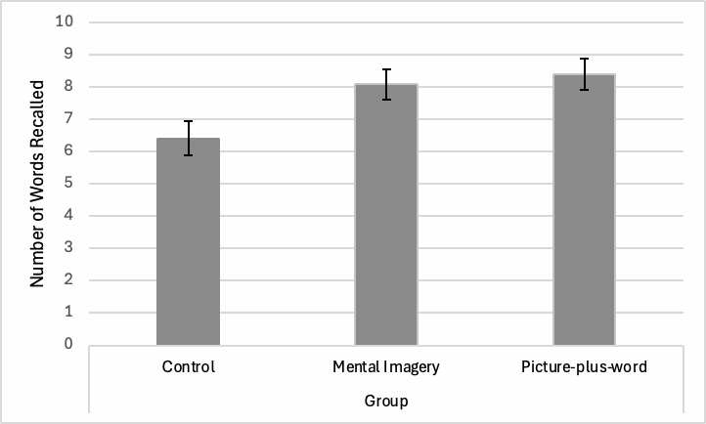

These results support our first hypothesis that both the visual imagery and dual coding conditions will have significantly better recall performance than the control. Regarding our alternative hypotheses comparing the visual imagery and dual coding groups, these findings support the theoretical framework presented by Paivio and Csapo (1973), since there was no difference in recall performance between these conditions. This suggests that the pictorial representations formed by visual imagery are as strongly encoded and as effective in improving memory performance as pictorial cues formed from viewing physical images.

**Discussion**

This study examined how visual imagery impacts explicit free recall performance when compared to mental rehearsal (control) and dual coding (pictures-plus-words). Our results revealed a significant difference in recall performance for the three conditions in our experiment, as the control group had significantly worse recall performance than both the visual mental imagery and dual coding groups. This is consistent with prior research on mental imagery and all aforementioned theoretical frameworks (embodied cognition theory, depth of processing, and dual coding), demonstrating that mental imagery is a more effective memorization strategy than mental rehearsal (the default strategy used by the control group). This result was hypothesized due to the memory benefits of encoding both visual and verbal memory traces, as opposed to simply verbal memory traces (consistent with dual coding) and the deeper processing produced by consciously and effortfully imagining the stimuli (consistent with depth of processing).

Our results also demonstrate no significant difference in recall performance between the visual imagery and dual coding conditions. Thus, our findings are most consistent with Paivio and Csapo’s (1973) dual coding theory instead of McCauley et al.’s (1996) depth of processing framework, which proposed that the visual imagery group would have better recall performance than the dual coding group. Visual imagery satisfies dual coding and enhances memory, similarly to viewing actual images, by producing both visual and verbal cues (Paivio & Csapo, 1973). Ultimately, this experiment demonstrated the positive memory effects of visual memory traces for both imagined and actual images, highlighting the effectiveness of visual mental imagery as a memorization strategy.

**Directions for Future Research**

Future research should continue exploring the positive memory effects of visual imagery and relevant theoretical frameworks. As such, researchers should further assess individual differences in mental imagery use and ability. In our manipulation check, we verified that participants in the visual imagery condition formed a mental image of the stimuli and that participants in the control condition did not, having participants report their use of mental imagery and vividness of mental images on a 1–5 scale. We conducted a *t*-test, which showed there was significantly more mental imagery use in the visual imagery condition (mean = 3.52, *SD* = 1.44) compared to the control condition (mean = 2.45, *SD* = 1.26), and this effect was medium to large, *t*(44) = -2.637, *p* = 0.006, Cohen’s *d* = 0.791. Interestingly, a *t*-test for the vividness of mental images revealed that the visual imagery and control conditions did not differ significantly and the effect was very small (but in the expected direction), *t*(44) = -0.477, *p* = 0.318, Cohen’s *d* = 0.14. These results demonstrate considerable variation in mental imagery use and vividness across participants. Some participants in the visual imagery group rated vividness very low (1–2), and various participants in the control group utilized mental imagery and rated vividness very high (4–5). Researchers should explore this individual variation in mental imagery abilities and whether it correlates with better recall performance (i.e., does higher vividness of mental images result in better performance?).

Researchers should also examine the practical implications of mental imagery by investigating its effectiveness as a memorization strategy for different demographics. Research by McCauley et al. (1996) demonstrated that using visual imagery or pictures-plus-words did not improve memory and even impaired it for older participants (compared to younger). They propose this is due to limited and divided attention, as older participants struggle to allocate their attention to multiple stimuli simultaneously (such as a picture and a word). Thus, mental imagery should be studied across age groups and with patient populations (i.e., with neuropsychiatric and cognitive impairments) to examine which groups would benefit most from using this strategy.

**Limitations of Experiment**

One possible limitation of our experiment was participants experiencing fatigue; they completed seven experiments (including ours) over 1–2 hours, which could confound the results of this study. Furthermore, participants completed multiple experiments that required memorization of wordlists, which can cause interference (the interaction between earlier and later learned information) and alter our results by affecting participants’ recall abilities.

Another limitation of our experiment is that various participants in the control condition reported using mental imagery as a memorization strategy and rated the vividness of imagined stimuli very highly (4–5). This may have affected our results by masking differences between the control and visual imagery conditions. Participants in the control condition who used mental imagery may have had better recall performance due to the benefits of this memorization strategy. As such, we could improve the design of this experiment by explicitly instructing the control condition to repeat the wordlist in their mind, encouraging the use of mental rehearsal as their memorization strategy.

**Theoretical & Practical Implications**

This experiment can have broader implications within learning and memory, since we assessed the effectiveness of several memorization strategies in explicit free recall. Furthermore, we examined the formation of visual and verbal memory traces and their effectiveness in enhancing memory performance. Our findings are most consistent with Paivio and Csapo’s (1973) dual coding theory, as compared to the deeper processing and elaboration framework proposed by McCauley et al. (1996). Thus, this study can have theoretical implications by further clarifying which framework best explains the positive memory effects of mental imagery.

This study can also have practical applications for memory and learning in the education and healthcare systems, as well as daily life. For example, students may benefit from using mental imagery to effectively memorize course material. Medical practitioners can implement mental imagery strategies for patients with neuropsychiatric and cognitive impairments (i.e., dementia and Alzheimer’s) to potentially counteract memory deterioration. Mental imagery could also improve our memory in day-to-day life, as we could better recall information if we try to visually imagine it (e.g., where we last saw our car keys).

**Conclusion**

This study contributes to knowledge within learning and memory by demonstrating that visual mental imagery and forming visual memory traces for both imagined and actual images improve recall performance. These findings are most consistent with Paivio and Csapo’s (1973) dual coding theory, suggesting that visual imagery improves recall by producing both visual and verbal cues, in a similar manner to viewing actual images. Furthermore, these results suggest that the pictorial mental representations formed by visual imagery are as strongly encoded and effective in enhancing memory performance as pictorial cues formed from viewing physical images. By demonstrating the effectiveness of visual imagery as a memorization strategy, this research has practical applications within education and healthcare, as mental imagery could improve the memory of student and patient populations.

**References**

Maisto, A. A., & Queen, D. E. (1992). Memory for pictorial information and the picture superiority effect. *Educational Gerontology*, *18*(2), 213–223. <https://doi.org/10.1080/0360127920180207>

Marre, Q., Huet, N., & Labeye, E. (2021). Embodied mental imagery improves memory. *The Quarterly Journal of Experimental Psychology, 74*(8), 1396–1405. <https://doi.org/10.1177/17470218211009227>

McCauley, M. E., Eskes, G., & Moscovitch, M. (1996). The effect of imagery on explicit and implicit tests of memory in young and old people: A double dissociation. *Canadian Journal of Experimental Psychology / Revue Canadienne De Psychologie Expérimentale, 50*(1), 34–41. <https://doi.org/10.1037/1196-1961.50.1.34>

Paivio, A., & Csapo, K. G. (1973). Picture superiority in free recall: Imagery or dual coding?. *Cognitive Psychology, 5*(2), 176–206. <https://doi.org/10.1016/0010-0285(73)90032-7>

**AI Statement**

GenerativeAI resources were not utilized for this experiment or research report.

**Appendix A**

***Stimuli Presented to Participants***

In our experiment, participants were asked to memorize and recall 15 stimuli. These stimuli were presented as words in the control and visual imagery conditions and as pictures-plus-words in the dual coding condition. The stimuli presented to participants in all three conditions included the following items: zebra, candle, flower, hammer, balloon, doctor, pillow, pasta, dolphin, pencil, laptop, glasses, jacket, arrow, and lemon.

For the dual coding condition, these words were presented as pictures-plus-words, as exemplified below for “zebra” and “candle”.

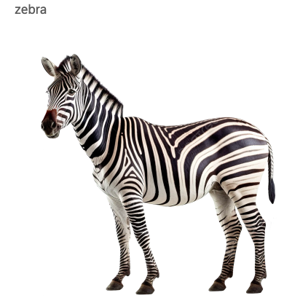

**Appendix B**

***Consent Form***

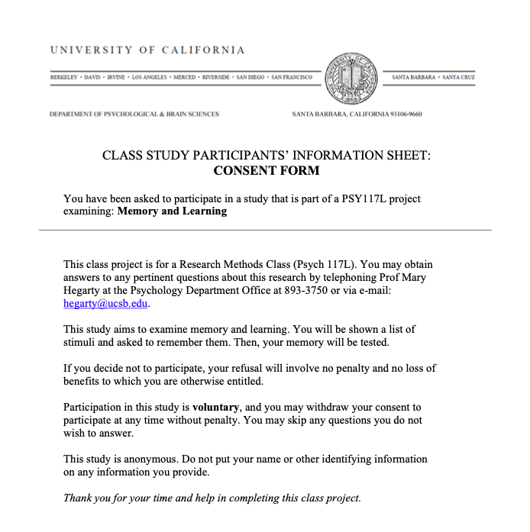

**Appendix C**

***Debriefing Form***

